
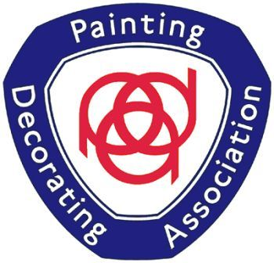
G.G. DINELEY & SONS
Established 1938
Painting & Decorating Contractors
UK and Ireland 2014 Painters Of The Year Finalist
Members of the Painting and Decorating Association
Safe-T-Cert Approved
Public and Employers Liability Insurance Cover

I would like to introduce you to G G Dineley & Sons, a renowned painting & decorating contractor founded in Newtownards in 1938, with a presence in Hong Kong since 1996.

A family business, G G Dineley & Sons provides extremely efficient services across the board, including internal and external painting, multi-colour spraying, fire retardant paint systems and ceiling and wall papering – the company can offer industry-recognised Muraspec and Vescom flame retardant wall coverings at a reasonable price to Northern Ireland’s business and private sectors.

As members of the Painting and Decorating Association, Constructionline, G G Dineley & Sons operates to the highest standards of health and safety and holds a Safe-T- Cert qualification.

All G G Dineley & Sons’ estimates include pricing on site, and measured terms to determine labour and material costs on a day/work basis. The firm also holds Employers and Public Liability insurance cover, both for £10,000,000 and registered tax exempt with the Inland Revenue on its invoiced payments. G G Dineley & Sons asks for invoices to be settled on or before 30 days following the invoice date.

G G Dineley & Sons is committed to delivering a prompt and satisfactory service to all its clients, employing only qualified tradesmen with CSR accreditation.

Previous clients include S.E. Education & Library Board, Belfast Cathedral, Kingsland Care Home, NI. Cancer fund for children, Dignity Funeral Care, Belfast Office Properties, Property One Management Co. Carrowdor and Quintin Castle’s and many more.

We hope you will consider utilising G G Dineley & Sons for any painting & decorating requirements you may have. For further information on our services or to schedule an estimate, please contact us by phone, email or in person.

Yours sincerely

GEORGE DINELEY (Partner)
For G.G. DINELEY & SONS

